

CHALLENGE NAME: [Hue of Deception]   
DEV: [Utkarsh Shirsath]

CATEGORY: [Steganography]   
LEVEL: [Medium]

2025



CHALLENGE NAME: [Hue Of Deception]

**Challenge Description**:

The SS General "Ulrich Theodor Tobias Ignatius Isidor" - III

is taking assistance of world-famous Dutch cryptographer  
"Pieter Otto Richard Theodoor Anton" to secure his confidential messages from enemy intervention  
  
Can you intercept this message?

**Solution:**

**Step 1: -** Reading the description,

If you notice the first letters of the name of the Dutch Cryptographer it spells “PORTA” referring to the porta cypher.

Now, if you know or try to find some basic info about the Porta cypher then you’ll understand that it requires a key.

Now, following the need for a key, if you notice the name of SS General is enclosed similarly in double quotes. That is the key for the cypher “uttii”

Step 2: - Using exiftool on the image we following riddle,

“A wheel of twelve, a dance of hue,

Spin thrice around, the path is true.

Skip and jump, not one by one,

Leap by two till the cycle is done...

The colors you seek, a hidden key,

An ancient gate shall set you free.

A name of old, a cipher’s art,

A general’s past shall play its part.”

First part of the riddle tells you; you need to go around the circle thrice skipping 2 colours until the cycle is complete.

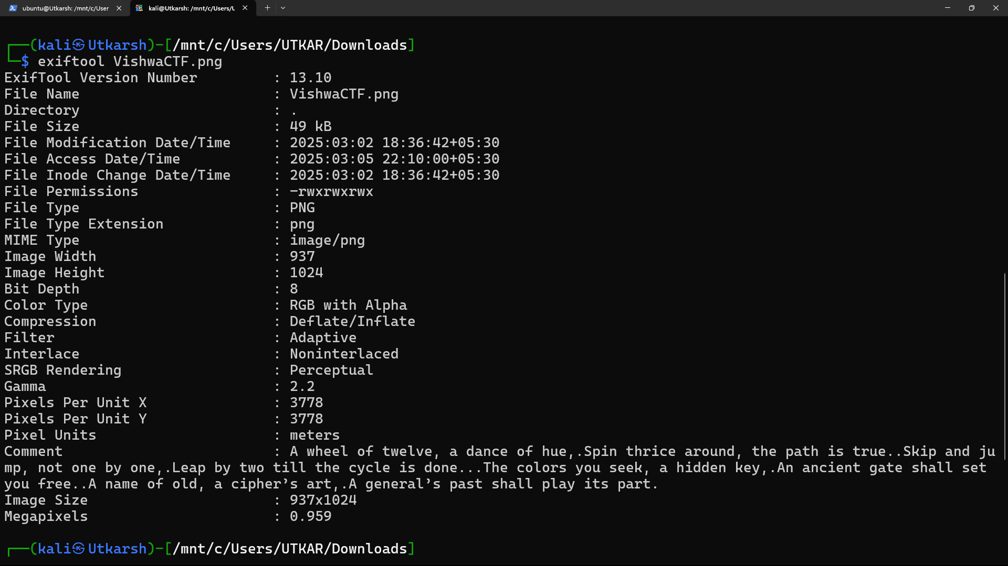

Now the question arises what is supposed to be done while going around in the circles.

s

This is where the hint comes into picture.

“Colours and their hexes weave a bigger picture.”

Step 3: -

We go around the circle collecting their hexes in the decoded sequence.

Now, how do we get the hexes?

While there are countless tools available for this, here I’ll be using Figma’s website

Website Link: - <https://www.figma.com/color-picker/>

From this we get the following list of hex codes: -

E07A5F

81B29A

3A5253

B9375E

FFE0E9

F0A830

F07818

78C0A8

5E412F

FCEBB6

BF6C85

A1EAF2

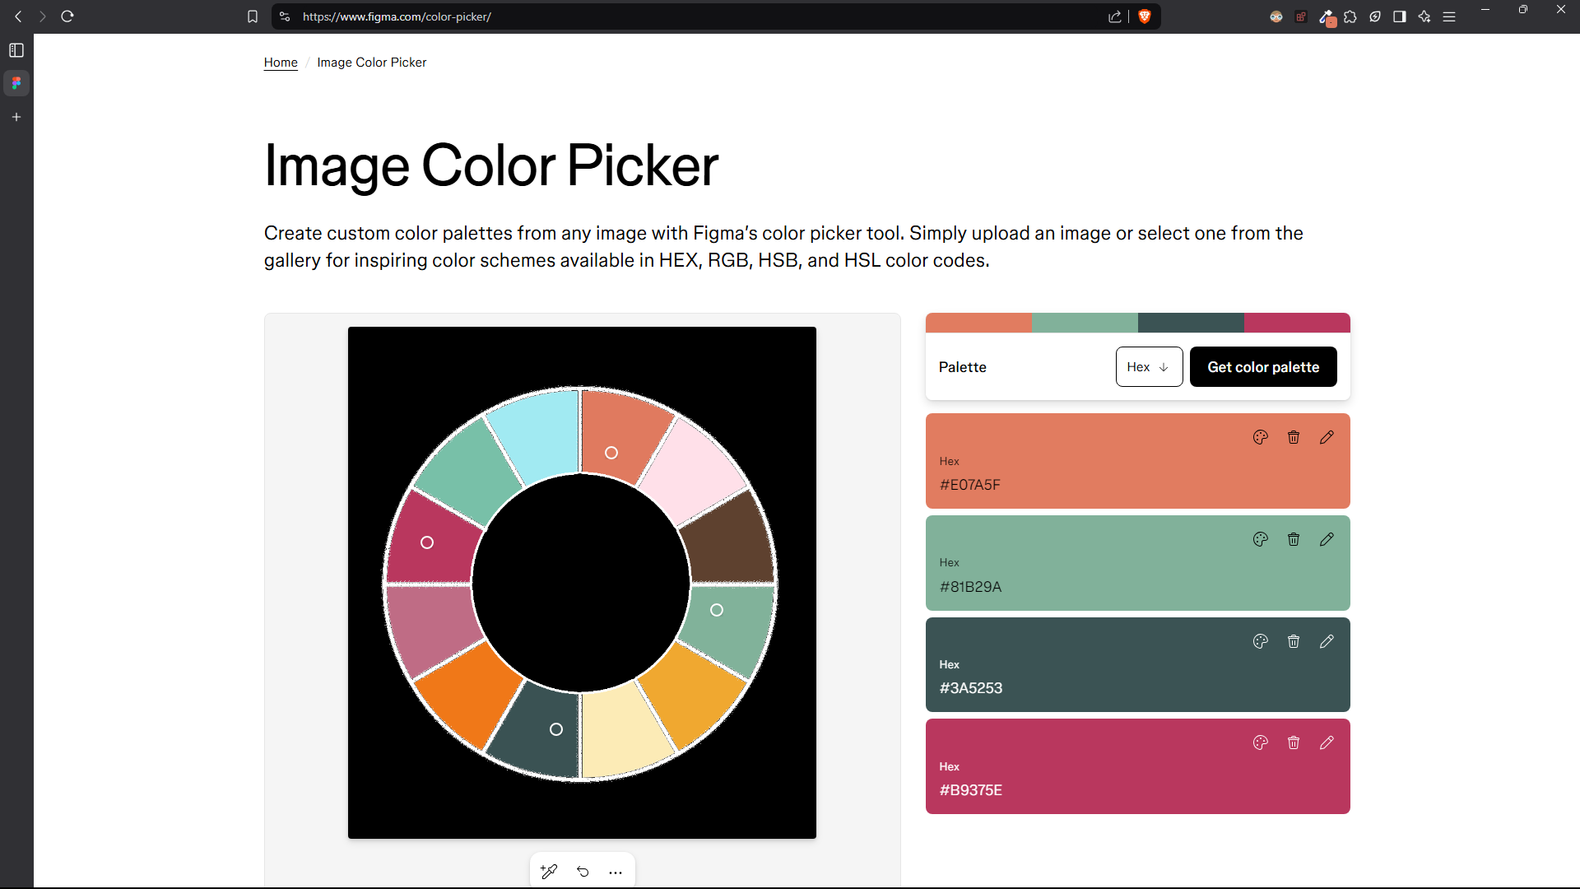

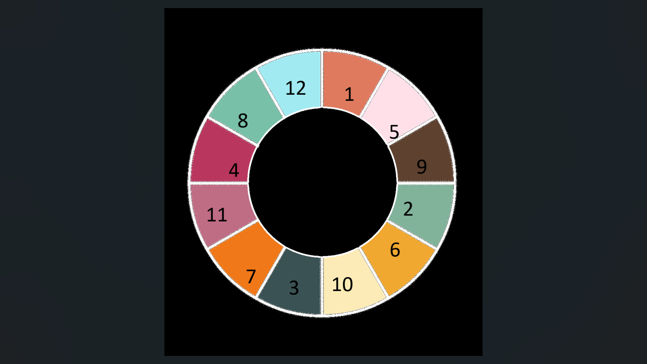

**Step 4: - Now just enter the Key “uttii” along with the hexcodes “E07A5F81B29A3A5253B9375EFFE0E9F0A830F0781878C0A85E412FFCEBB6BF6C85A1EAF2” in Porta cypher and you have the flag**

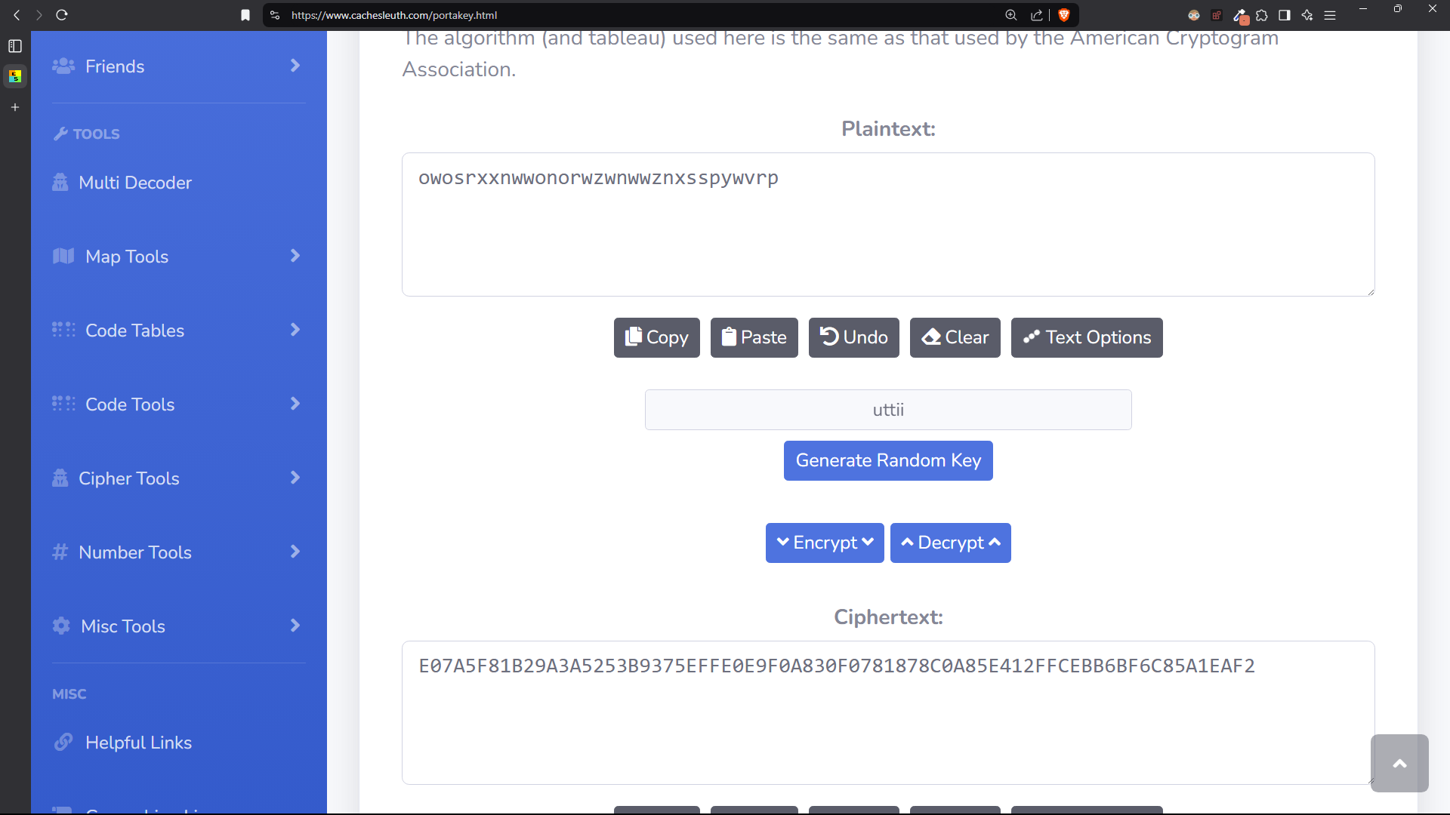

**Website Link : -** [**https://www.cachesleuth.com/portakey.html**](https://www.cachesleuth.com/portakey.html)

**Flag: VishwaCTF{owosrxxnwwonorwzwnwwznxsspywvrp}**

DEV: [] **1**